**REPUBLIC OF CAMEROON REPUBLIQUE DU CAMEROUN**

**Peace – Work – Fatherland**   **Paix – Travail – Paitrie**



**FACULTY OF ENGINEERING AND TECHNOLOGY**

**DEPARTMENT OF COMPUTER ENGINEERING**

**SPECIALIZATION: SOFTWARE ENGINEERING**

**COURSE TITLE: SOFTWARE QUALITY TOOLS AND TESTING**

**ASSESSMENT AND FEATURE REQUIREMENT FOR TELEMEDCINE APP:**

**MEDIK**

|  |  |  |
| --- | --- | --- |
|  | **NAMES** | **MATRICULE NUMBERS** |
| **1** | **QUINUEL TABOT NDIP-AGBOR** | **FE21A300** |
| **2** | **INDAH RICOBELLE MBAH** | **FE21A204** |
| **3** | **SIRRI THERESIA ANYE** | **FE21A306** |
| **4** | **TSAPZE ZAMBOU ROSELINE** | **FE21A328** |
| **5** | **ENOW MYKE-AUSTINE ETA** | **FE21A183** |
| **6** | **MOKFEMBAM FABRICE KONGNYUY** | **FE21A240** |
| **7** | **MONDOA ROBERT** | **FE21A241** |
| **8** | **TAKEM JIM** | **FE21A309** |
| **9** | **KENFACK SAMEZA** | **FE21A213** |
| **10** | **FOLETIA AJONGAKUI SYNCLAIR** | **FE21A190** |

**COURSE INSTRUCTOR: DR. TSAGUE ALINE**

**TABLE OF CONTENTS**

**I.** **INTRODUCTION** 3

**II.** **PROJECT DETAILS, REQUIREMENT DESCRIPTION AND STANDARDS ANALYSIS** 4

1) **FUNCTIONAL REQUIREMENTS** 4

2) **NON-FUNCTIONAL REQUIREMENTS** 5

3) **INTERNATIONAL QUALITY STANDARDS FOR TELEMEDICINE APPS** 6

III. ANALYSIS AND RESEARCH ILLUSTRATION FOR MEDIK 7

1) **OVERVIEW** 7

2) **ANALYSIS** 7

3) **RESEARCH** 9

4) **ILLUSTRATION** 9

IV DESIGN……………………………………………………………

IV. 5) **Benefits Of MEDIK To The Cameroonian Population** …………

**CONCLUSION**…………………………………………………………………………………………………………………………. 12

**V.REFERENCE**……………………………………………………………… 13

# I. INTRODUCTION

Telemedicine applications, also known as telehealth apps, have emerged as transformative tools in the healthcare landscape. These mobile applications enable individuals to access healthcare services remotely, bridging geographical distances and overcoming mobility challenges. By leveraging the power of smartphones and other digital devices, telemedicine applications are revolutionizing the way healthcare is delivered and consumed.

MEDIK, a leading telemedicine application, stands at the forefront of this transformative movement. MEDIK offers a comprehensive suite of services designed to provide convenient and accessible healthcare to individuals from all walks of life. The application's core functionalities include:

* **Real-time video and audio consultations:** MEDIK empowers patients to connect with licensed healthcare providers via secure video or audio calls, enabling face-to-face interactions for diagnosis, treatment planning, and follow-ups.
* **Secure messaging:** MEDIK facilitates seamless communication between patients and healthcare providers through a secure messaging platform, allowing for asynchronous exchanges of information, questions, and concerns.
* **Online prescription generation:** MEDIK streamlines the prescription process by allowing healthcare providers to electronically generate and send prescriptions directly to pharmacies, eliminating the need for paper prescriptions.
* **Pharmacy services:** MEDIK integrates with partner pharmacies, enabling patients to conveniently order and receive medications directly through the application.
* **Appointment scheduling:** MEDIK simplifies appointment scheduling, allowing patients to browse available time slots and book appointments with their preferred healthcare providers directly from the app.
* **Personalized health notifications:** MEDIK goes beyond consultations and prescriptions by providing personalized health notifications based on a patient's medical history, lab test results, and diagnoses. These notifications may include health tips, medication reminders, and follow-up appointment prompts.

MEDIK's comprehensive suite of features caters to a wide range of healthcare needs, from routine checkups and prescription renewals to chronic disease management and mental health counseling. The application's user-friendly interface and secure communication protocols make it accessible to individuals of all ages and technical proficiency.

In a world where healthcare accessibility is often hindered by geographical barriers, mobility limitations, and time constraints, telemedicine applications like MEDIK are paving the way for a more equitable and inclusive healthcare system. By bridging the gap between patients and healthcare providers, these applications are empowering individuals to take control of their health and well-being.

# II. PROJECT DETAILS, REQUIREMENT DESCRIPTION AND STANDARDS ANALYSIS

#### 1) FUNCTIONAL REQUIREMENTS:

Functional Requirements describe what a system must do. They specify the functions and features that the system must provide to meet the user's needs.

➢ **User Authentication and Security:**

* Secured user registration and login using multiple authentication factors, including username, password, and biometric fingerprint.
* Enforced password complexity and change requirements.
* Secure storage and encryption of user credentials and personal data.
* Implementation of role-based access control (RBAC) to restrict access to sensitive information.
* Regular security audits and vulnerability assessments.

➢ **Patient-Healthcare Provider Communication and Consultation:**

* Real-time video, audio, and messaging communication between patients and healthcare providers.
* Scheduling and management of virtual consultations.
* Secure file sharing for exchanging medical records, images, and other relevant documents.
* Integration with third-party communication platforms.
* Real-time translation services for multilingual communication.

➢ **Payment Processing and Transactions**

* Integration with secure payment gateways for online transactions.
* Support for multiple payment methods (credit cards, debit cards, mobile wallets).
* Generation of detailed transaction receipts for consultations, diagnosis, and medication purchases.
* Secure storage and processing of payment information.
* Compliance with relevant payment industry standards (PCI DSS).

➢ **Appointment Scheduling and Management**

* Real-time scheduling and management of appointments for both patients and healthcare providers.
* Availability of appointment slots based on healthcare providers' schedules.
* Synchronization with healthcare providers' calendars and scheduling systems.
* Automated appointment reminders and notifications.
* Waitlist management for oversubscribed appointments.
* Integration with patient calendars for seamless scheduling.

➢ **Medical Records Management**

* Secure and centralized storage of patient medical records, including test results, prescriptions, and other relevant health information.
* Patient-controlled access to their medical records.
* Sharing of medical records with healthcare providers with patient consent.
* Data encryption and access logging for audit purposes.
* Compliance with relevant data privacy regulations (HIPAA, GDPR).
* Integration with electronic health record (EHR) systems for comprehensive patient data management.

➢ **Prescription Services**

* Electronic prescription (eRx) generation and management.
* Direct transmission of prescriptions to pharmacies.
* Patient consent management for sharing prescription information with pharmacies.
* Integration with pharmacy management systems.
* Medication affordability and delivery options, including generic drug recommendations and pharmacy discounts.

### 2) NON-FUNCTIONAL REQUIREMENTS:

### Security and Privacy:

* MEDIK adheres to strict security standards (e.g., HIPAA compliance) to ensure the confidentiality, integrity, and privacy of patient data.
* MEDIK provides assurance and sustainable database to store and duplicate data of patients for medical and research purposes.
* **Usability and User Experience:**
* MEDIK has an intuitive and user-friendly interface, making it easy for users to navigate, schedule appointments, communicate, and access their information.
* **Performance and Scalability:**
* MEDIK is capable of handling concurrent users and providing a smooth and responsive experience, even during peak usage times.
* **Reliability and Availability:**
* MEDIK is reliable, ensuring consistent availability and minimal downtime to avoid disruptions in accessing healthcare services.
* **Compatibility and Integrations:**
* The app should be compatible with various devices, operating systems (e.g., iOS, Android), and browsers to cater to a wide range of users.
* It should also support integrations with other healthcare systems, such as electronic health records (EHR) or pharmacy systems.
* **Accessibility:**
* MEDIK will comply with accessibility standards to ensure that individuals with disabilities can access and use the app effectively.
* **Regulatory Compliance:**
* The app should adhere to relevant regulations and guidelines, such as HIPAA, GDPR, and local telemedicine practice guidelines.
* **Internationalization:**
* MEDIK is multilingual and can be used across 50+ international languages.

### 

### 3) INTERNATIONAL QUALITY STANDARDS FOR TELEMEDICINE APPS:

Internationally socially used standards include:

* **Health Insurance Portability and Accountability Act (HIPAA):** HIPAA sets the standards for protecting sensitive patient health information in the United States. If your telemedicine app serves users in the U.S., compliance with HIPAA regulations is crucial to safeguard patient privacy and security.

* **General Data Protection Regulation (GDPR):** GDPR is a comprehensive data protection regulation that applies to the European Union (EU) and European Economic Area (EEA). If your telemedicine app serves users in EU/EEA countries, compliance with GDPR is necessary to ensure the lawful and secure processing of personal data.

* **International Organization for Standardization (ISO) 27001:** ISO 27001 is an internationally recognized standard for information security management systems. Adhering to ISO 27001 guidelines helps ensure that your telemedicine app implements robust security controls, risk management processes, and data protection measures.

The professional descriptions of most commonly used international standards for telemedicine apps include:

* **Health Level 7 (HL7) :** HL7 is an international standard for the exchange of electronic health record (EHR) data. It is a comprehensive standard that covers a wide range of clinical and administrative data, including patient demographics, diagnoses, medications, allergies, and laboratory results. HL7 is widely used in telemedicine applications to exchange data between different healthcare systems.

* **Digital Imaging and Communications in Medicine (DICOM):** DICOM is an international standard for the exchange of medical images, such as X-rays, CT scans, and MRI scans. DICOM is widely used in telemedicine applications to transmit medical images from one location to another for consultation or diagnostic purposes.

* **Fast Healthcare Interoperability Resources (FHIR):** FHIR is a newer standard that is based on modern web technologies, such as JSON and HTTP. FHIR is designed to be more flexible and easier to implement than HL7, and it is gaining popularity in the telemedicine industry.

## III. ANALYSIS AND RESEARCH ILLUSTRATION FOR MEDIK

#### 1) OVERVIEW

Telemedicine is the use of telecommunications technology to provide healthcare services remotely. The telemedicine app, MEDIK, is out to provide patients with convenient and affordable access to healthcare services, especially for those in rural or underserved areas.

#### 2) ANALYSIS

MEDIK is a telemedicine app that provides patients with a variety of services, including:

* Video, audio and messages consultations with healthcare providers
* Prescription management
* Medical records management
* Secure communication
* Appointment scheduling
* Patient education materials
* Pharmacy services

MEDIK is a user-friendly app that is easy to navigate. The app is also secure and compliant with all applicable privacy regulations.

#### 3) RESEARCH

There is a growing body of research that supports the effectiveness of telemedicine apps. For example, a study published in the Journal of the American Medical Association found that telemedicine was as effective as in-person care for a variety of conditions, including chronic diseases and mental health conditions. And Fig 1. Below shows an illustration of MEDIK’s details

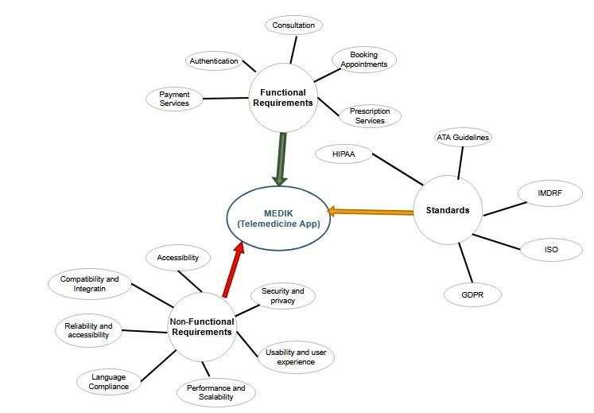

#### 4) ILLUSTRATION

Imagine a patient named Sarah who lives in a rural area. Sarah has a chronic disease that requires regular monitoring. In the past, Sarah had to drive for hours to see her doctor. However, now that she has MEDIK, she can schedule a video consultation with her doctor from the comfort of her own home.

**IV DESIGN**

**1. SYSTEM DESIGN**

**2. UI DESIGN**

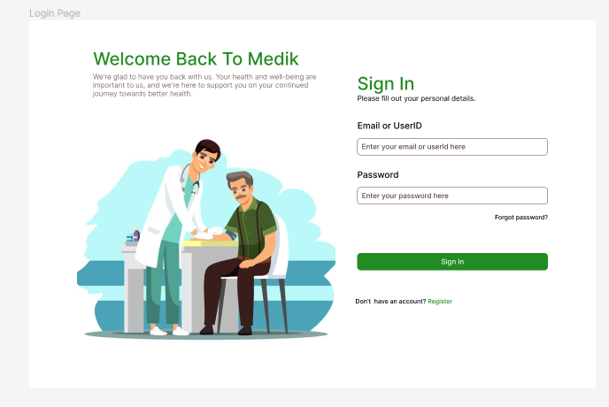

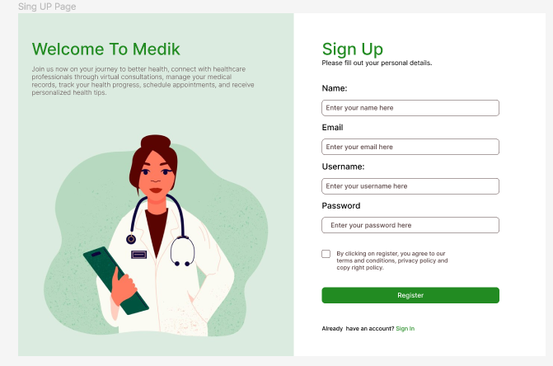

**3. DATABASE DESIGN**

The database has been developed using MySql workbench.

This database consists of seven tables that store the information as seen on the above ER diagram. Having this amount of tables, strengthens the security of the system such that the won’t be any interference with data, ensures data integrity and avoid conflicts.

**Software Quality Model for MEDIK Telemedicine App**

**Purpose**

The purpose of this software quality model is to define the quality attributes and requirements for the MEDIK telemedicine app. This model will be used to guide the development and testing of the app to ensure that it meets the needs of its users and stake holders.

**Scope**

This software quality model applies to all aspects of the MEDIK telemedicine app, including its functionality, performance, security, usability and reliability.

**Quality Attributes**

The following quality attributes are important for the MEDIK telemedicine app:

• Functionality: The app must meet all of the functional requirements that have been defined for it.

• Performance: The app must be able to handle concurrent users and provide a smooth and responsive experience, even during peak usage times.

• Security: The app must be secure and protect patient data from unauthorized access.

• Usability: The app must have an intuitive and user-friendly interface that is easy for users to navigate, schedule appointments, communicate and access their information

• Reliability: The app must be reliable and ensure consistent availability with minimal downtime to avoid disruptions in accessing healthcare services.

• Compatibility: The app should be compatible with various devices, operating systems (e.g IOS, Android), and browsers to cater to a wide range of users.

• Accessibility: The app will comply with accessibility standards to ensure that individuals with disabilities can access and use the app effectively.

• Regulatory Compliance: The app should adhere to relevant regulations and guidelines, such as HIPAA, GDPR and local telemedicine patience guidelines.

• Language accessibility: MEDIK is lingual friendly and can be used across 50+ international languages.

**Quality Requirements**

The following quality requirements are associated with the identified quality

attributes:

**Functionality**

• The app must provide all of the features and functions that have been defined

in the functional requirements.

• The app must be able to handle all of the use cases that have been identified.

• The app must be able to perform all of the business processes that have been

defined.

Performance

• The app must be able to handle concurrent users and provide a smooth and

responsive experience, even during peak usage times.

• The app must be able to load and display data quickly.

• The app must be able to perform all of its functions without experiencing any

performance bottlenecks.

**Security**

• The app must use secure authentication and authorization mechanisms.

• The app must store and transmit patient data securely.

• The app must be protected from vulnerabilities and attacks.

**Usability**

• The app must have an intuitive and user-friendly interface that is easy for

users to navigate.

• The app must be easy to learn and use.

• The app must be accessible to users with disabilities.

Reliability

• The app must be available 99.9% of the time.

• The app must be able to recover from failures quickly.

• The app must be able to handle unexpected events and gracefully degrade

when necessary.

**Compatibility**

• The app should be compatible with various devices, operating systems (e.g.,

iOS, Android), and browsers to cater to a wide range of users.

• The app should support integrations with other healthcare systems, such as

electronic health records (EHR) or pharmacy systems.

**Accessibility**

• The app will comply with accessibility standards to ensure that individuals with

disabilities can access and use the app effectively.

Regulatory Compliance

• The app should adhere to relevant regulations and guidelines, such as

HIPAA, GDPR, and local telemedicine practice guidelines.

**Language accessibility:**

• The app will support multiple languages and provide an option for the user to

choose their preferred language.

• The app will be translated correctly across all languages supported.

**SOFTWARE TESTING**

The following types of testing will be used to ensure that the MEDIK telemedicine

app meets its quality requirements:

• Unit testing: Unit testing will be used to test individual components of the app.

• Integration testing: Integration testing will be used to test how different

components of the app work together.

• System testing: System testing will be used to test the app as a whole.

• Performance testing: Performance testing will be used to test the app's

performance under load.

• Security testing: Security testing will be used to identify and fix vulnerabilities

in the app.

• Usability testing: Usability testing will be used to ensure that the app is easy to

use.

Conclusion

This software quality model provides a comprehensive framework for ensuring that

the MEDIK telemedicine app meets the needs of its users and stakeholders. By

following this model, the development team can ensure that the app is functional,

performant.

**SYSTEM TESTING**

System testing for telemedicine apps is crucial to ensure the functionality, usability, and reliability of the application. It involves validating all the features and functionality of the app to ensure they meet the required standards. Here are some key aspects we took into consideration when analyzing medik

1. Device interoperability:

When app is developed, it should be very compatible, that is it should be able to run on all OS, ANDROIDS AND IOS

1. Application responsiveness:

When app is developed, it should have a good processing speed, flexible performance for the convenience of users. This is tested by navigating the site, such as menus, displaying information.

3. Data security: Test the app's security measures to ensure patient data is protected and encrypted during transmission and storage

5. Validation of functionality: Test all the features and functionalities of the app, such as

appointment scheduling, video calling, prescription management, and health record access, to

ensure they work as intended.

7. Data precision and verification: Validate the accuracy and integrity of patient data entered

into the app, such as health parameters, medical history, and prescriptions

8. Risk-based testing: Prioritize and execute testing activities based on the impact of risks in

different functional software modules

10. Testing of finance system: Ensure the proper functioning of financial processes, such as

payroll management and payments to different sources

By conducting comprehensive system testing, telemedicine apps can deliver a high-quality end-

product, provide a satisfactory user experience, and ensure the security and reliability of

healthcare services

**5) Benefits of MEDIK To The Cameroonian Society**

MEDIK will offer a number of benefits including:

* Increased access to healthcare: MEDIK will provide patients with access to healthcare services that they might not otherwise have. This is especially beneficial for patients in rural or underserved areas.
* Convenience: MEDIK will allow patients to see their doctor from the comfort of their own home. This can save patients time and money.
* Affordability: MEDIK will be more affordable than traditional in-person care.
* Improved quality of care: MEDIK will improve the quality of care by providing patients with more timely and convenient access to healthcare services.

**III. CONCLUSION**

In conclusion, MEDIK MEDIK offers a user-friendly interface that enables patients to conveniently access virtual consultations with licensed healthcare professionals from the comfort of their homes. Through secure video calls and messaging systems, patients can receive medical advice, diagnoses, and even prescriptions, saving time and eliminating the barriers of distance and transportation.

With a strong focus on patient privacy and data security, our app complies with international professional standards such as HIPAA and GDPR. We have implemented robust encryption protocols and stringent access controls to ensure the confidentiality and integrity of patient information, instilling trust and confidence in our users.

presents a comprehensive solution that addresses the evolving needs of healthcare delivery in the digital age. By leveraging the power of technology, we aim to revolutionize the way patients and healthcare providers connect and interact, ultimately enhancing access to quality healthcare services.

Furthermore, MEDIK integrates seamlessly with existing healthcare systems through adherence to HL7 standards, enabling efficient sharing and exchange of electronic health information. This interoperability enhances care coordination and streamlines the healthcare workflow, leading to improved patient outcomes and operational efficiency.

Our team of experienced healthcare professionals, software developers, and user experience designers are collaborating for the production of MEDIK that prioritizes user satisfaction and clinical effectiveness. We have incorporated evidence-based guidelines from reputable organizations like the ATA and WHO to ensure that our app adheres to the highest industry standards.

In summary, MEDIK offers a transformative solution that empowers patients and healthcare providers alike. By embracing technology and adhering to international professional standards, we are redefining healthcare delivery, making it more accessible, efficient, and patient-centric. Join us on this journey as we shape the future of healthcare through our innovative telemedicine app.

**IV. REFERENCE:**

1. **Google Bard AI :** [**https://bard.google.com/**](https://bard.google.com/) visited lastly on the 07/011/2023

1. Health Insurance Portability and Accountability Act (HIPAA)
   * Book: ***HIPAA: A Practical Guide for Covered Entities and Business Associates* by Laurie A. Morgan**

Author: **Laurie A. Morgan**

Publication Date: **2022**

**3)**International Organization for Standardization (ISO) 13485:2016

* + Book: ***ISO 13485:2016 Quality Management Systems - Medical Devices -***

***Application of ISO 9001:2015 for Regulatory Purposes* by John Woodcock**

Author: **John Woodcock**

Publication Date: **2018**

1. International Electrotechnical Commission (IEC) 60601-1

• Book: ***IEC 60601-1:2005 Medical electrical equipment - General requirements for safety* by International Electrotechnical Commission**

Author: **International Electrotechnical Commission**

Publication Date: **2005**

1. Medical Device Directive (MDD)

• Book: ***The Medical Device Directive - A Practical Guide for Medical Device***

***Manufacturers* by Peter Chapman**

Author: **Peter Chapman**

Publication Date: **2013**

1. Medical Device Regulation (MDR)

• Book: ***The Medical Device Regulation - A Practical Guide for Medical Device Manufacturers* by Peter Chapman**

Author: **Peter Chapman**

Publication Date: **2020**

1. World Health Organization (WHO) Recommendations for Telemedicine

• Book**:** ***WHO Recommendations for Telemedicine: Digital technologies for health* by World Health Organization**

Author: **World Health Organization**

Publication Date: **2021**

**8)** International Telecommunication Union (ITU) Guidelines for Telemedicine

• Book: ***ITU Guidelines for Telemedicine: Use of telecommunication/information and communication technologies (ICT) for the delivery of health care services at a distance* by International Telecommunication Union**

Author: **International Telecommunication Union**

Publication Date: **2015**